
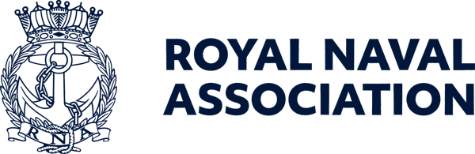

Semaphore Short Friday 28 August 2026

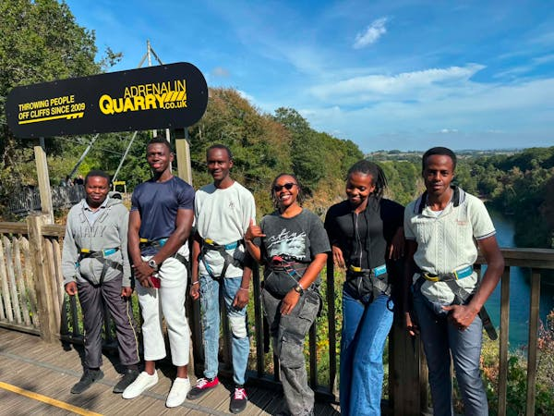

A summer to remember for overseas recruits

Among those taking part in Liskeard RNA's 40th anniversary celebrations this month were overseas and Commonwealth recruits from HMS Raleigh, who were on leave and being supported by the RNA.
This support was made possible through the generosity of shipmates who donated to our Boost a Recruit campaign, which is also heavily backed by funding from Royal Navy and Royal Marines Charity (RNRMC).
These young sailors – some of them pictured above at an activities session – are often unable to travel home during this time, and their presence at the anniversary parade was a powerful reminder that the RNA's commitment extends beyond supporting veterans – it is also helping the next generation of sailors feel connected, supported and valued as they begin their Royal Navy careers.
Through wellbeing activities, social events and practical support, the Boost a Recruit campaign helps combat isolation and build morale during leave periods.
Whilst HMS Raleigh provides excellent training and support, there is still tremendous value in the little things that help lift morale, especially when many recruits have gone home and only a handful are still in Raleigh over leave periods.
Your contribution could help fund a pizza night, or cinema tickets, or a social activity that brings the recruits together and strengthens camaraderie, resilience and wellbeing
These may seem like small gestures, but they can make a huge difference to a recruit's experience – simply knowing that someone cares enough to support them can provide a valuable boost during what could otherwise be a lonely time.
If you'd like to help our future sailors feel valued and connected, please consider making a donation today – the link is: https://tinyurl.com/2x9he574

Sign up for the Uckers World Championships

There is still time to register your interest in joining the quest for a world championship.
Hosted by the Royal Naval Association at the Royal Maritime Hotel in Portsmouth on Saturday 3 October, the Uckers World Championships is open for registration from 0900 to 1000, and players of any standard, from novice to expert, are welcome.
The first dice are cast at 0930, and spectators are most welcome to watch proceedings, which promise plenty of thrills and excitement.
You can enter the competition as a solo player or part of a team of two, and we are keen to see ships and establishments represented – you could be playing for the honour of your shipmates.
To help us plan, please register your interest by emailing ceo-ea@rnassoc.org with your name, contact details and whether you're entering solo or with a teammate.

Strong support for CONA

We’re delighted to say that more than 70 delegates have now registered for CONA 2026.
It’s wonderful to see such strong engagement across the Naval community, and we look forward to welcoming everyone to the Royal Maritime Hotel in Queen Street, Portsmouth, on 11 September.
We are putting together the Delegate Information Packs, which will be handed out on the day of the conference.
If your Association has any updates, promotional material, upcoming events they wish to publicise, or other items you’d like included, please send them over to Milly on ceo-ea@rnassoc.org by close of play on Monday 7 September.
Including your content is a great way to highlight your Association’s activities and ensure delegates have a clear picture of the breadth of work taking place across our community.
Thank you for your continued support – we are very much looking forward to what promises to be a fantastic event.
There are limited spaces left, so if you would like to attend please contact Milly as soon as possible – CONA provides a forum for representatives of Naval associations across the UK to network, share ideas, strengthen connections and discuss issues of importance to their members and to the wider Naval community.

Overpayment of Armed Forces pensions

There has been a growing interest in the media about the issue of overpayment of some Armed Forces pensions and the requirement to repay sums of money that have in some cases run to several thousands of pounds.
It would seem that there have been issues relating to Pension Sharing Orders, Early Departure Payments, Guaranteed Minimum Pension and National Insurance Abatement, though there also appear to have been more general errors in calculations.
If you have been affected by this situation – most likely via a letter from Equiniti – then the experts at the Forces Pension Society have advice on what your next steps should be.
Their advice includes the need to first of all verify that the Infiniti letter is genuine, as such situations could attract the attention of scammers.
For further information see the FPS website at https://forcespensionsociety.org/2026/08/overpayment-of-pension-errors/
The White Ensign Association is also an organisation which specialises in dealing with issues over Forces pensions – see https://www.whiteensign.co.uk

Are you pension aware?

And talking of the White Ensign Association (WEA), the organisation says that your Armed Forces pension is one of the most valuable benefits of Service, and is making efforts to help you understand yours.
As part of the MOD's Pension Awareness Week 2026, the WEA is hosting a free live webinar for serving personnel, reservists and veterans, covering AFPS 75, 05 and 15, plus Early Departure Payments.
WEA Armed Forces Pension experts Dave Scholey and Marty Small, themselves Royal Navy and Royal Marines veterans, will explain the schemes, what they mean for their members and answer questions throughout the live session.
The webinar will be held on Wednesday 16 September, 1300–1430, online via MS Teams.
Know your scheme. Know your entitlements. Know your choices. Be pension aware!
You must register to attend: https://events.teams.microsoft.com/event/317d7a71-f9e3-48e1-a572-119a56acfd70@9e902c46-439c-4b5d-b4ae-572ded6ed2b9

Fireside Chat

Our next scheduled Fireside Chat is delivered by former RNA General Secretary Bill Oliphant, who will speak on the subject of the Royal Navy's attack on Fort Henry and the Star-Spangled Banner.
The monthly Fireside Chats are an opportunity to be educated and amused by knowledgeable speakers on a wide range of topics concerning the Naval and maritime community.
You don't even need to be a member to join one of these online events (though we would encourage you to join the Association anyway...).
The Zoom link is in the 'Online events' section of the RNA website at https://www.royal-naval-association.co.uk/virtual-events

Bidding still open for unique anniversary rum barrel

Shipmate Wally Blagden has created a unique 2.5 litre anniversary rum barrel that celebrates several historic Naval anniversaries, and the barrel is up for auction, with bidding currently standing at £500.
Money raised will be donated to the RNA Central Charity Fund.
The barrel includes several special coins, including a King George VI 1950 halfpenny (representing the RNA's 75 anniversary last year), a mint 1970 Galleon halfpenny (for the 56th anniversary of Black Tot Day), and a King Charles III 2026 mint £5 crown, which celebrates 500 years of the crown coin.
Wally has recently added an 1805 copper King George III halfpenny to the barrel marking the 221st Anniversary of the Battle of Trafalgar.
The new barrel was created following a similar initiative marking the 50th anniversary of Black Tot Day, when ten decorated rum barrels and plaques were auctioned to raise funds for Naval charities.
Bidding will close on 3 October to coincide with the RNA World Uckers Championships in Portsmouth.
If you would like to make a bid for this special item of Naval memorabilia, you can send it to RNA Central Office at ceo-ea@rnassoc.org and we will pass it on to Wally.



Exclusive book offer for RNA members

RNA members have an exclusive opportunity to purchase a signed hardback copy of best-selling author Hugh Sebag-Montefiore’s acclaimed book Battle of the Arctic for just £22 plus postage.
This special, limited-time offer has been arranged exclusively for RNA members ahead of Hugh’s visit to CONA next month.
To secure your signed hardback edition, simply email: ceo-ea@rnassoc.org. Copies are available on a first-come, first-served basis and this exclusive RNA member offer is expected to generate considerable interest.
Battle of the Arctic shines a light on one of World War 2’s most demanding and often overlooked campaigns: the Arctic Convoys, described by Churchill as “the worst journey in the world.”
RNA members can also register their interest in attending either of Hugh’s upcoming speaking engagements:
- Conference of Naval Associations (CONA) – 11 September
- RNA Fireside Chat – 2 November
To purchase a signed copy of the book or register for either event, please email: ceo-ea@rnassoc.org

  Shop for the Association
  You could turn your everyday shopping into support for the RNA without spending an extra penny.
  Whether you're buying gifts, booking a holiday, or ordering your weekly essentials online, you could be raising free donations for the Royal Naval Association through easyfundraising.
  Simply sign up, select the RNA as your chosen charity, and participating retailers will donate on your behalf at no additional cost to you.
  It’s free to join, there are thousands
  

of retailers involved, and every donation helps support members, veterans, and their families
Start fundraising the easy way – use this link: https://tinyurl.com/54b34d42 or use the QR code (above right). You just need to click ‘Support this Cause’, create a free account, and start shopping with participating retailers via the website, app or browser extension.
Once you’re registered, donations will be automatically generated whenever you make eligible purchases.

Remembrance Sunday ceremonies in London

We still have a limited number of places remaining in the RNA contingent which will march along Whitehall in London on Remembrance Sunday.
Any shipmates interested in marching with the RNA at the November ceremonies in London should register their interest by emailing JB at ams@rnassoc.org no later than 15 September.
Please note – those registering with the RNA will be expected to march with the 140-strong RNA contingent.
In order to march you must possess at least one of the following:
• Veterans Recognition (ID) Card
• Veterans UK Status Card
• Certificate of Service – this must include date of discharge
• Certificate of Discharge
• Veterans Railcard
• For Merchant Mariners – a copy of the personal details page of your Discharge Book, along with the vessel names on which you served and the operation names and date.
Please check the RBL website for eligibility details: https://tinyurl.com/c9w445fa
Remembrance Sunday this year is 8 November.
Following the Cenotaph parade, the RNA will host a sandwich lunch reception for 50 members (on a first come, first served basis) at the Civil Service Club at 13-15 Great Scotland Yard, London SW1A 2HJ.



Maldives holiday is top prize in draw

This summer, Royal Navy & Royal Marines Charity is one of the beneficiary charities of the RaiseHero 50/50 Raffle.
Enter from just £5 for your chance to win incredible prizes – including a holiday for two in the Maldives – while helping to support those who serve in the Royal Navy, Royal Marines and Royal Fleet Auxiliary.
The main draw takes place on 30 September, with the prize being a luxury Maldives holiday for two, promising white-sand beaches, crystal-clear waters and £10,000 cash to spend. Or you could take home a £20,000 cash alternative.
And if you spend £25 or more you’ll be entered into a bonus draw to win £1,000 cash.
There are also weekly bonus prizes, so the earlier you enter, the more bonus draws you'll be eligible for the following:
- Apple smartwatch – 2 September
- Fortnum & Mason hamper – 9 September
- Ninja coffee machine – 15 September
- Nintendo Switch – 22 September
Every entry supports the Royal Navy & Royal Marines Charity, with 50 per cent of tickets purchased helping those who serve, have served, and their families.
For full details of the raffle and rules see https://tinyurl.com/y4cpkfpp

Fly the flag for the Merchant Navy

A reminder that you can show your support for the civilian mariners next week by flying the Red Ensign on Merchant Navy Day – Thursday 3 September.
For more details see https://www.theseafarerscharity.org/get-involved/merchant-navy-day

 |  |  |  |  |  |  |  |  |  |  | 

